FACULTY EVALUATION
Programme Name: SBVP ALUMNI MASTERCLASS Online s Module 2 Kenya: (4th May 2026 - 8th May 2026)
Session: Long-term sustainability planning
Faculty Name: Dr. Mary Moraa Aminga
No. of Respondents: 22
No. of Participants: 22
Evaluation Parameter | (%) Individual Score | (%) Programme Average
Punctuality (Commencement and Completion of Sessions) | 96 | 95
How well do you understand the core concepts presented? | 93 | 90
Rate your confidence in applying the new skills learnt | 89 | 85
Degree of Faculty preparedness for the sessions | 96 | 96
Content and methodology of the program | 95 | 93
Quality of class and group discussions | 91 | 90
The information presented in the course is relevant to my work (ministry) | 95 | 94
Average scores | 94 | 92

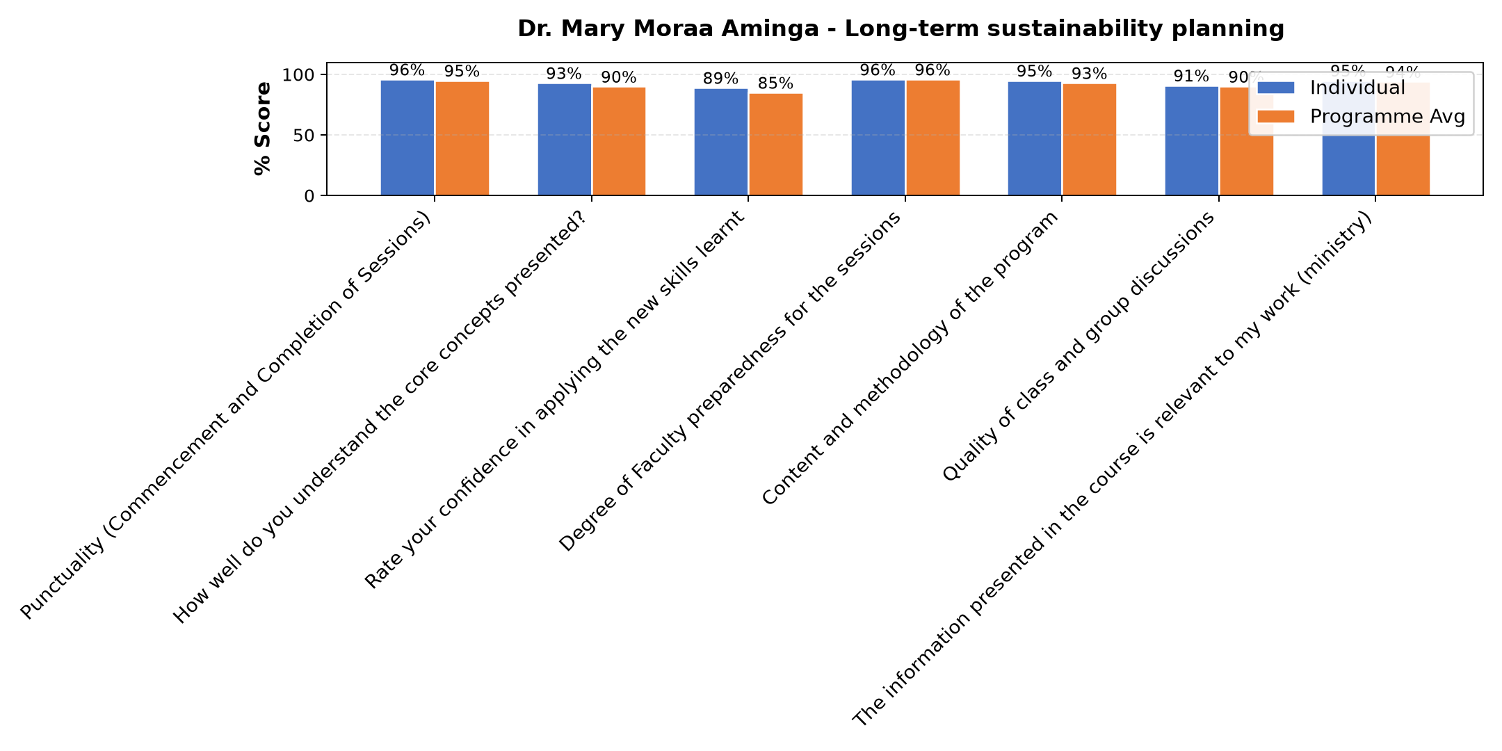

Comments & Feedback
- • The process of decision making takes long to implement something
- • Finance
- • The knowledge recieved is good enough to start applying the skills where possible
- • Lack of putting what have learned into practice.
- • Experience
- • The collection of data
- • Lack of important data for monitoring and evaluation of social impact
- • Financial problem and competition.
- • Uncertainty of resources mobilization
- • Well presentation
SUBMITTED THROUGH:
SBS Evaluation Automation System

